Introduction
The State Design Pattern is a behavioral design pattern that is simple yet very useful. It is highly use-case specific and appears frequently in specific LLD interview questions.
Key idea: An object can exist in a limited number of states at a time. When an operation is performed on the object, it may transition from one state to another.

Why It's Important
- Appears in many LLD interview questions (Vending Machine, ATM, Document Editor)
- Makes code loosely coupled (a core LLD principle)
- Ensures code is easy to understand and maintain
- Allows objects to alter their behavior when their internal state changes

Prerequisite: State Machine Diagram (SMD)
The State Machine Diagram (from Theory of Computation - TOC) is essential for understanding this pattern. It's a simple diagram showing:
- All possible states of an object
- All possible operations/methods that can be performed
- Transitions between states based on which operation is performed

How to Draw an SMD
Example Structure:
- An object Obj with 4 states: A, B, C, D
- 4 methods: M1, M2, M3, M4
Transitions:
- State A + M1 → State B
- State B + M2 → State C
- State C + M3 → State D
- State D + M4 → State A
Other permutations are possible:
- State A + M2 → State C (skips B)
- State A + M3 → State D
or
- State A + M2 → State A (no state change, stays in same state)
- State B + M1 → State D (or stays in B)
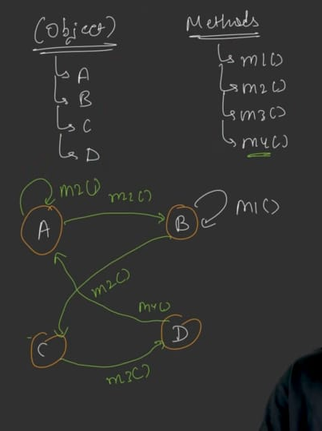

Key Properties
- Finite number of states: The object has a limited, fixed number of states
- Finite number of methods: The object supports a limited, fixed number of operations
- Each (state, method) pair either:
  - Transitions to a new state
  - Stays in the same state (no change)
When to use the State Pattern: When you have an object with a limited number of states, limited operations, and each operation on any state may cause a state transition.

Real-World Example: Vending Machine

Why Vending Machine is a Good Example
- Operates in a limited number of states
- Limited number of operations
- State Pattern makes it loosely coupled, easy to understand, and maintainable
- A standard interview question

The Vending Machine Structure
A basic vending machine has:
- Items stored inside (e.g., water bottles)
- Screen/Panel to display messages
- Keypad to enter item codes
- Coin slot to insert coins
- Dispenser to deliver the item
- Coin return mechanism
Simplification for this example:
- Only water bottles (all at ₹20 each)
- Only coin insertion accepted (no UPI/Paytm)
- One product type

The Four States
State | Description
NoCoinState | Vending machine is idle; no coin inserted yet
HasCoinState | A coin has been inserted; machine can accept operations
DispenseState | Item is being dispensed (falling into dispenser)
SoldOutState | All items are exhausted

The Five Operations (Methods)
Operation | Description
insertCoin | User inserts a coin (e.g., ₹10)
selectItem | User selects an item from the keypad
dispense | Machine dispenses the item
returnCoin | Machine returns the money to user
refill | Admin refills the machine with items

State Machine Diagram for Vending Machine

Basic Transitions
text
NoCoinState --[insertCoin]--> HasCoinState
HasCoinState --[selectItem]--> DispenseState
DispenseState --[dispense]--> NoCoinState (if items remain)
DispenseState --[dispense]--> SoldOutState (if no items left)
SoldOutState --[refill]--> NoCoinState

Detailed Transition Matrix
Current State | insertCoin | selectItem | dispense | returnCoin | refill
NoCoinState | → HasCoinState | Stay (error) | Stay (error) | Stay (error) | Stay (refill done)
HasCoinState | Stay (accumulate) | → DispenseState | Stay (error) | → NoCoinState | Stay (error)
DispenseState | Stay (error) | Stay (error) | → NoCoinState OR SoldOutState | Stay (error) | Stay (error)
SoldOutState | Stay (error) | Stay (error) | Stay (error) | Stay (error) | → NoCoinState

Why States Stay in Place (No Transition)
NoCoinState:
- insertCoin → transitions to HasCoinState (accepts coin)
- selectItem → error: "Please insert coin first"
- dispense → error: "No coin, no item selected"
- returnCoin → error: "No coin to return"
- refill → refills but stays in NoCoinState (no coin added)
HasCoinState:
- insertCoin → stays in HasCoinState (accumulates more coins; e.g., ₹10 + ₹10 = ₹20)
- selectItem → transitions to DispenseState (if sufficient balance; else stays)
- dispense → error: "Please select item first"
- returnCoin → transitions to NoCoinState (returns coins and resets)
- refill → error: "Can't refill while transaction in progress"
DispenseState:
- insertCoin → error: "Already dispensing item"
- selectItem → error: "Already dispensing item"
- dispense → transitions to NoCoinState OR SoldOutState (depending on remaining items)
- returnCoin → error: "Item already dispensed"
- refill → error: "Can't refill while dispensing"
SoldOutState:
- insertCoin → error: "No items to sell"
- selectItem → error: "No items"
- dispense → error: "No items"
- returnCoin → error: "No coin inserted"
- refill → transitions to NoCoinState (items restocked)

Detailed State Diagram with Return Coin
- HasCoinState has TWO possible transitions:
  - selectItem → DispenseState
  - returnCoin → NoCoinState

Example Scenarios
Scenario 1: Insert ₹10, then ₹10
- NoCoinState + insertCoin(₹10) → HasCoinState (balance: ₹10)
- HasCoinState + insertCoin(₹10) → HasCoinState (balance: ₹20) — state doesn't change but operation succeeds
Scenario 2: ₹10, select ₹20 item
- HasCoinState + selectItem → stays in HasCoinState with error "Insufficient funds, need ₹10 more"
Scenario 3: ₹20, select ₹20 item, dispense
- HasCoinState + selectItem → DispenseState (balance sufficient)
- DispenseState + dispense → NoCoinState (items remaining) OR SoldOutState (last item)

Tabular Representation Summary
State | insertCoin | selectItem | dispense | returnCoin | refill
NoCoinState | HasCoinState | NoCoinState | NoCoinState | NoCoinState | NoCoinState
HasCoinState | HasCoinState | DispenseState | HasCoinState | NoCoinState | HasCoinState
DispenseState | DispenseState | DispenseState | NoCoinState / SoldOutState | DispenseState | DispenseState
SoldOutState | SoldOutState | SoldOutState | SoldOutState | SoldOutState | NoCoinState
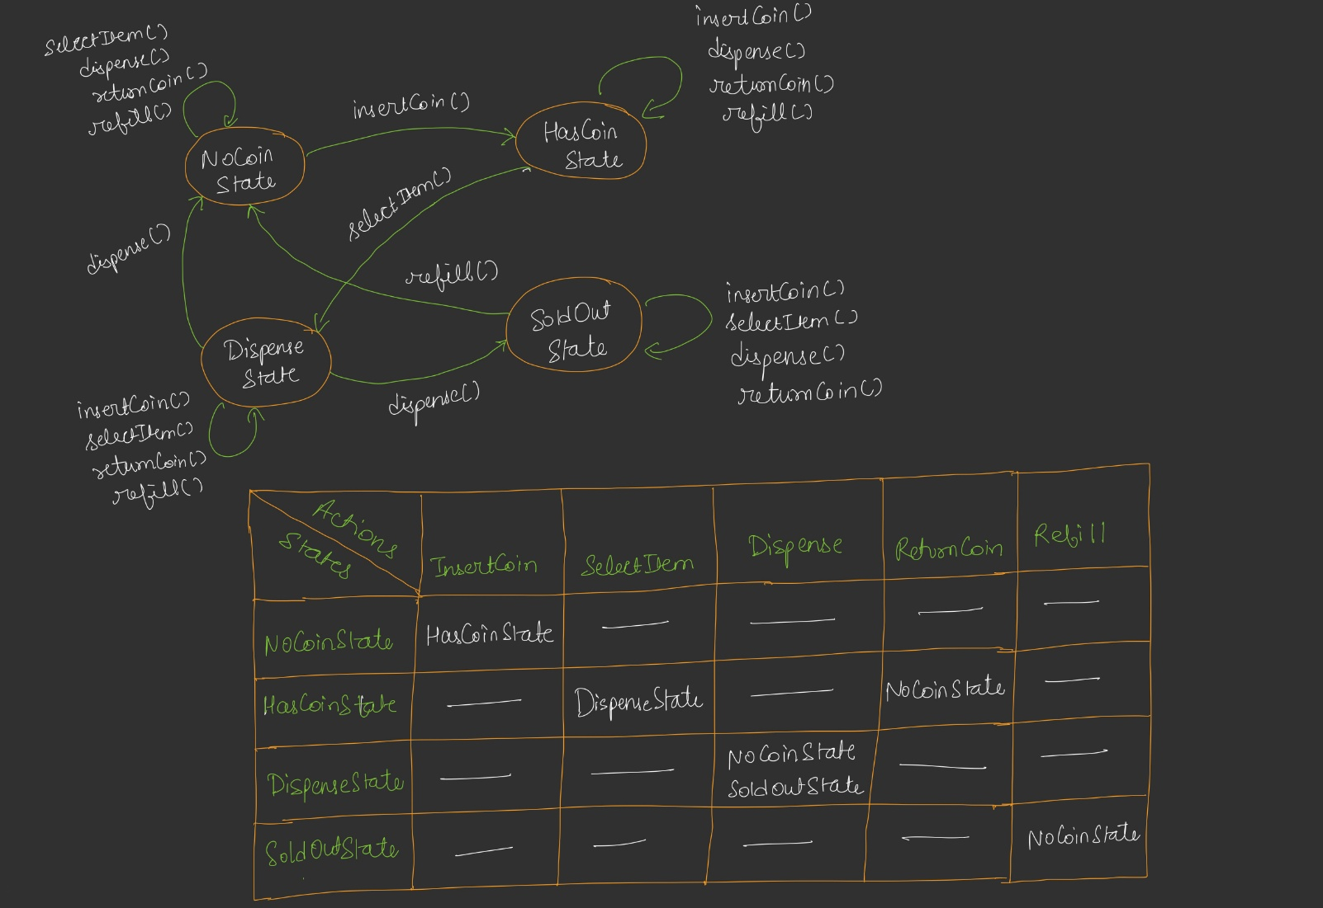
returnCoin()

UML Design

Class Hierarchy

text
┌─────────────────────┐
│ VendingMachineState│ <<abstract>>
├─────────────────────┤
│ + insertCoin() │
│ + selectItem() │
│ + dispense() │
│ + returnCoin() │
│ + refill() │
│ + getStateName() │
└─────────────────────┘
▲
┌───────────────┼───────────────┬────────────────┐
│ │ │ │
┌───────────┐ ┌────────────┐ ┌────────────┐ ┌───────────┐
│ NoCoinState│ │HasCoinState│ │DispenseState│ │SoldOutState│
└───────────┘ └────────────┘ └────────────┘ └───────────┘
│ │ │ │
└───────────────┴───────────────┴────────────────┘
(all hold references to each other)

Context Class (Vending Machine)
text
┌─────────────────────────────────┐
│ VendingMachine │ <<Context>>
├─────────────────────────────────┤
│ - currentState: VendingMachineState │
│ - noCoinState: VendingMachineState │
│ - hasCoinState: VendingMachineState │
│ - dispenseState: VendingMachineState│
│ - soldOutState: VendingMachineState │
│ - itemCount: int │
│ - itemPrice: int │
│ - insertedCoins: int │
├─────────────────────────────────┤
│ + VendingMachine(count, price) │
│ + insertCoin(coin) │
│ + selectItem() │
│ + dispense() │
│ + returnCoin() │
│ + refill(quantity) │
│ + printStatus() │
│ + getters/setters for state & │
│ itemCount/insertedCoins │
└─────────────────────────────────┘

Key Relationships
- VendingMachine has-a currentState (polymorphic reference to abstract state)
- Concrete States inherit from abstract VendingMachineState
- Concrete States hold references to other concrete states (like Chain of Responsibility pattern)
- Methods return VendingMachineState — so the returned state updates the machine's current state

Important UML Details
- The abstract VendingMachineState declares all 5 operations as virtual methods
- Each concrete state overrides all methods
- Methods return VendingMachineState (the next state to transition to)
- Each concrete state also holds a reference to the VendingMachine (context), so it can:
  - Modify machine fields (insertedCoins, itemCount)
  - Access machine getters (itemPrice, insertedCoins)
- Concrete states also hold references to other concrete states (for returning next state)

Context Class (Vending Machine) — How It Works
The Vending Machine is a "dumb" object — it knows nothing about business logic. It just delegates all operations to its current state.
UML diagram:-
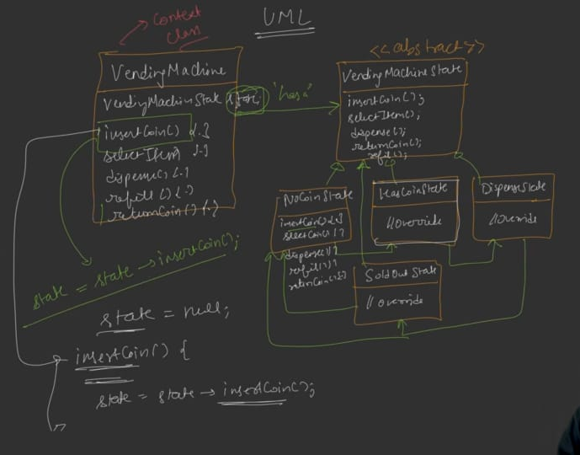
Clean UML Diagram:-
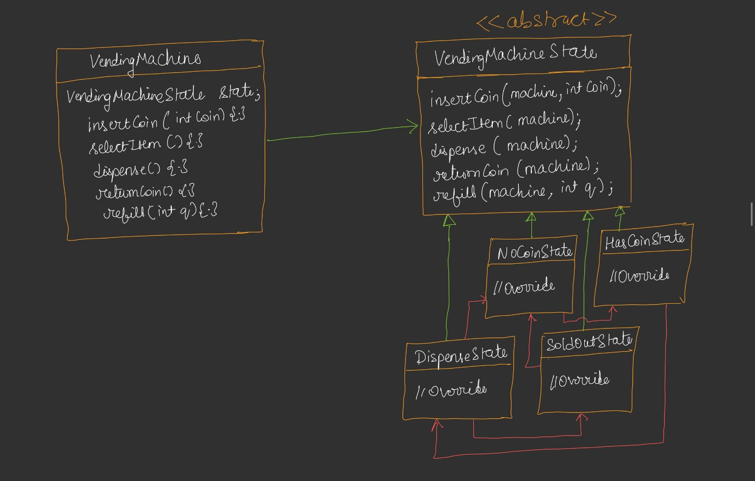

Delegation Pattern
java
class VendingMachine {
VendingMachineState currentState;
VendingMachineState noCoinState;
VendingMachineState hasCoinState;
VendingMachineState dispenseState;
VendingMachineState soldOutState;

int itemCount;
int itemPrice;
int insertedCoins;

VendingMachine(int itemCount, int itemPrice) {
this.itemCount = itemCount;
this.itemPrice = itemPrice;

// Instantiate all states once
noCoinState = new NoCoinState();
hasCoinState = new HasCoinState();
dispenseState = new DispenseState();
soldOutState = new SoldOutState();

// Set initial state
if (itemCount > 0) {
currentState = noCoinState;
} else {
currentState = soldOutState;
}
}

void insertCoin(int coin) {
currentState = currentState.insertCoin(this, coin);
}

void selectItem() {
currentState = currentState.selectItem(this);
}

void dispense() {
currentState = currentState.dispense(this);
}

void returnCoin() {
currentState = currentState.returnCoin(this);
}

void refill(int quantity) {
currentState = currentState.refill(this, quantity);
}
}

Why Pre-Instantiate States in Constructor?
- Avoids creating new objects on every transition (memory efficient)
- currentState gets updated by the return value from the state method
- All states are created once and reused via their references

Delegation Flow
text
Client → machine.insertCoin(₹10)
↓
currentState.insertCoin(machine, ₹10)
↓
Returns HasCoinState reference
↓
currentState = HasCoinState
Meaning: Vending machine doesn't know HOW operations work; it just calls currentState.operation() and stores the returned state.

Concrete State Implementations

NoCoinState
java
class NoCoinState implements VendingMachineState {

VendingMachineState insertCoin(VendingMachine machine, int coin) {
machine.insertedCoins += coin;
System.out.println("Coin inserted. Current balance: ₹" + machine.insertedCoins);
return machine.getHasCoinState(); // transition
}

VendingMachineState selectItem(VendingMachine machine) {
System.out.println("Please insert coin first.");
return machine.getNoCoinState(); // stay
}

VendingMachineState dispense(VendingMachine machine) {
System.out.println("Dispense not allowed. Insert coin and select item first.");
return machine.getNoCoinState();
}

VendingMachineState returnCoin(VendingMachine machine) {
System.out.println("No coin inserted to return.");
return machine.getNoCoinState();
}

VendingMachineState refill(VendingMachine machine, int quantity) {
machine.itemCount += quantity;
System.out.println("Machine refilled with " + quantity + " items.");
return machine.getNoCoinState(); // stays in NoCoinState
}

String getStateName() { return "NoCoinState"; }
}

HasCoinState
java
class HasCoinState implements VendingMachineState {

VendingMachineState insertCoin(VendingMachine machine, int coin) {
machine.insertedCoins += coin;
System.out.println("Additional coin inserted. Balance: ₹" + machine.insertedCoins);
return machine.getHasCoinState(); // stays — can keep adding coins
}

VendingMachineState selectItem(VendingMachine machine) {
if (machine.insertedCoins >= machine.itemPrice) {
int change = machine.insertedCoins - machine.itemPrice;
if (change > 0) {
System.out.println("Returning change: ₹" + change);
}
machine.insertedCoins = 0;
return machine.getDispenseState(); // transition
} else {
int needed = machine.itemPrice - machine.insertedCoins;
System.out.println("Insufficient funds. Need ₹" + needed + " more.");
return machine.getHasCoinState(); // stay
}
}

VendingMachineState dispense(VendingMachine machine) {
System.out.println("Please select an item first.");
return machine.getHasCoinState();
}

VendingMachineState returnCoin(VendingMachine machine) {
System.out.println("Returning ₹" + machine.insertedCoins);
machine.insertedCoins = 0;
return machine.getNoCoinState(); // transition
}

VendingMachineState refill(VendingMachine machine, int quantity) {
System.out.println("Cannot refill while transaction in progress.");
return machine.getHasCoinState();
}

String getStateName() { return "HasCoinState"; }
}

DispenseState
java
class DispenseState implements VendingMachineState {

VendingMachineState insertCoin(VendingMachine machine, int coin) {
System.out.println("Please wait, already dispensing item.");
return machine.getDispenseState();
}

VendingMachineState selectItem(VendingMachine machine) {
System.out.println("Already dispensing item. Please wait.");
return machine.getDispenseState();
}

VendingMachineState dispense(VendingMachine machine) {
System.out.println("Dispensing item...");
machine.itemCount--;

if (machine.itemCount > 0) {
return machine.getNoCoinState(); // items remain
} else {
return machine.getSoldOutState(); // last item sold
}
}

VendingMachineState returnCoin(VendingMachine machine) {
System.out.println("Cannot return coin, item already dispensed.");
return machine.getDispenseState();
}

VendingMachineState refill(VendingMachine machine, int quantity) {
System.out.println("Cannot refill while dispensing.");
return machine.getDispenseState();
}

String getStateName() { return "DispenseState"; }
}

SoldOutState
java
class SoldOutState implements VendingMachineState {

VendingMachineState insertCoin(VendingMachine machine, int coin) {
System.out.println("Machine sold out. Cannot accept coin.");
return machine.getSoldOutState();
}

VendingMachineState selectItem(VendingMachine machine) {
System.out.println("No items available.");
return machine.getSoldOutState();
}

VendingMachineState dispense(VendingMachine machine) {
System.out.println("No items to dispense.");
return machine.getSoldOutState();
}

VendingMachineState returnCoin(VendingMachine machine) {
System.out.println("No coin to return.");
return machine.getSoldOutState();
}

VendingMachineState refill(VendingMachine machine, int quantity) {
machine.itemCount += quantity;
System.out.println("Machine refilled with " + quantity + " items.");
return machine.getNoCoinState(); // transition to NoCoinState
}

String getStateName() { return "SoldOutState"; }
}

Client Code Example (Main Method)
java
public static void main(String[] args) {
int itemCount = 2;
int itemPrice = 20;

VendingMachine machine = new VendingMachine(itemCount, itemPrice);
machine.printStatus();

// Trying to select item without coin
machine.selectItem(); // Error: please insert coin first

// Insert ₹10
machine.insertCoin(10);
machine.printStatus(); // HasCoinState, balance ₹10

// Try selecting item — insufficient
machine.selectItem(); // Error: need ₹10 more

// Insert another ₹10
machine.insertCoin(10);
machine.printStatus(); // HasCoinState, balance ₹20

// Select item
machine.selectItem(); // Transitions to DispenseState

// Dispense
machine.dispense(); // Transitions to NoCoinState (1 item left)
machine.printStatus();

// Buy second item
machine.insertCoin(20);
machine.selectItem();
machine.dispense(); // Transitions to SoldOutState
machine.printStatus(); // SoldOutState, 0 items

// Try inserting coin while sold out
machine.insertCoin(10); // Error: sold out
machine.refill(5); // Transitions to NoCoinState
}

Expected Output Walkthrough
- Initial: Items = 2, Coins = 0, State = NoCoinState
- selectItem without coin: "Please insert coin first"
- insert ₹10: State = HasCoinState, Balance = ₹10
- selectItem with ₹10: "Insufficient funds. Need ₹10 more"
- insert ₹10: Balance = ₹20
- selectItem: Transition to DispenseState
- dispense: Item dispensed, Items = 1, State = NoCoinState
- Buy second item (₹20):
  - insertCoin(₹20) → HasCoinState
  - selectItem → DispenseState
  - dispense → Items = 0, State = SoldOutState
- insertCoin while sold out: Error message
- refill(5): Items = 5, State = NoCoinState

Code ..see Notes

Standard UML Diagram

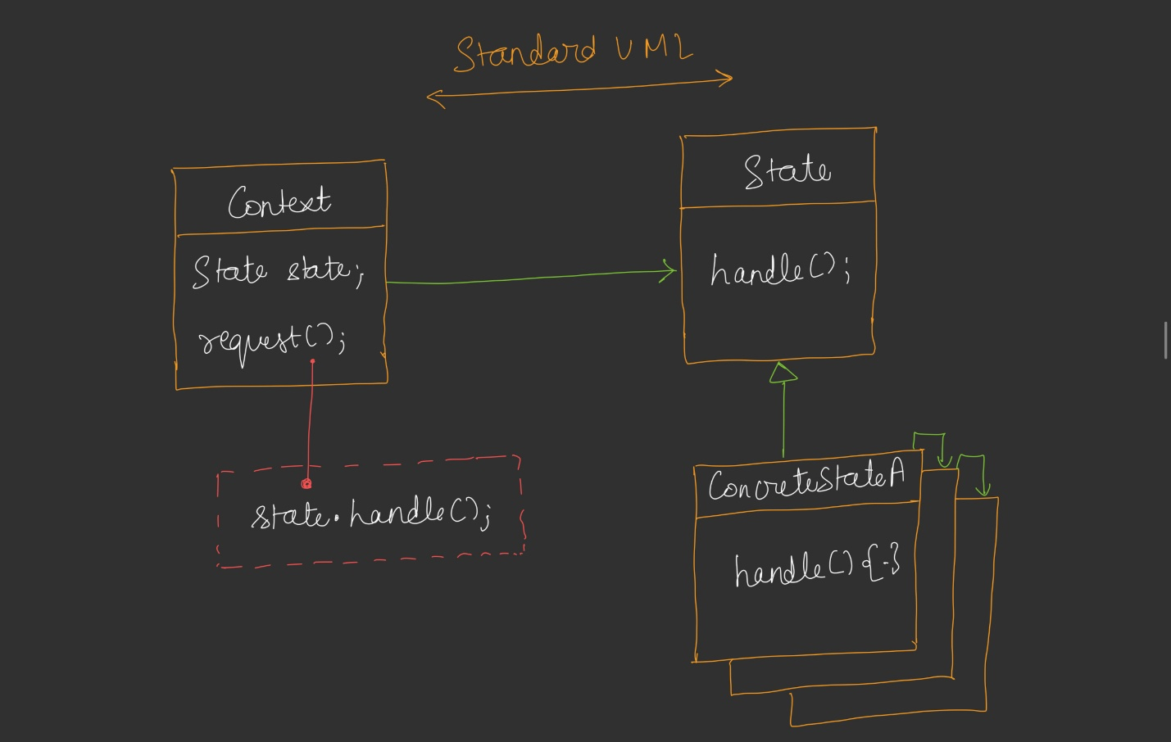Context Class Interface
- Context holds a state reference (polymorphic)
- Context exposes a request() method (or multiple methods)
- request() calls state.handle() and updates state with the returned value

Concrete State Transitions
- State A + handle() → returns State B reference
- State B + handle() → returns State C reference
- State C + handle() → returns State A reference (cycle)

Dual References
- Concrete State → references Context (to modify context state)
- Concrete State → references other Concrete States (to return next state)
Similar to Chain of Responsibility: Each concrete class holds a reference to another concrete class.

Standard Definition
"The State Pattern allows an object to alter its behavior when its internal state changes. The object will appear to change its class."

Breakdown
- "Alter its behavior": Same method, different behavior depending on state
- "Internal state changes": State transition happens internally, hidden from client
- "Appear to change its class": From client's perspective, the object seems to behave like a different class

Client's Perspective Example
- First call to insertCoin → accepts coin
- Second call to insertCoin (after state changed) → also accepts coin (accumulates)
- Then selectItem is possible, but not before inserting coin
- Client sees inconsistent behavior for the same method — but internal state explains it

Why Not Just Use If-Else?
Without State Pattern: A single VendingMachine class with one big set of methods, each containing many if-else statements for each state:
java
void insertCoin(int coin) {
if (currentState.equals("NO_COIN")) {
insertedCoins = coin;
currentState = "HAS_COIN";
} else if (currentState.equals("HAS_COIN")) {
insertedCoins += coin;
} else if (currentState.equals("DISPENSE")) {
// error: wait, dispensing
} else if (currentState.equals("SOLD_OUT")) {
// error: sold out
}
}

Problems with If-Else Approach
- Massive if-else chains for every operation × every state combination
- Violates Open/Closed Principle: Adding a new state requires modifying every method
- Hard to maintain: Difficult to trace logic for any state
- Error-prone: Easy to miss a branch
- Poor readability: Business logic buried in conditionals

State Pattern Benefits
- Each state is its own class: Logic for a state is centralized
- Open/Closed Principle: Adding a new state means adding a new class
- Loosely coupled: Vending machine doesn't know details of state behavior
- Single Responsibility: Each state class handles its own behavior
- Client transparency: Client doesn't see if-else logic — just calls methods

Real-World Use Cases

1. Vending Machine (Standard Interview Question)
- States: NoCoin, HasCoin, Dispense, SoldOut (+ can be extended: PaymentState, MaintenanceState)
- Operations: insertCoin, selectItem, dispense, returnCoin, refill

2. ATM Machine
- Idle State: ATM idle, waiting for card
- CardAccepting State: User inserted card, ATM is reading card
- Validation State: User entered PIN, ATM validates
- Transaction State: User performing withdrawal/deposit
- Card Ejecting State: Transaction complete, card being returned
- Combine with Chain of Responsibility for cash dispensing logic

3. Document Editor (e.g., GeeksforGeeks article system)
- Draft State: Document being drafted
- Published State: Document is live
- Archived State: Document archived
- Deleted State: Document deleted
- Operations: publish, archive, delete, restore, etc.

4. Order Management Systems (E-commerce)
- States: Created, Paid, Shipped, Delivered, Cancelled, Returned
- Operations: pay, ship, deliver, cancel, return

5. Media Player
- States: Playing, Paused, Stopped, Buffering
- Operations: play, pause, stop, next, previous

6. Traffic Light System
- States: Red, Yellow, Green
- Transition based on timer events

7. Game Character States
- States: Idle, Walking, Running, Jumping, Attacking
- Operations: move, jump, attack, stop

Key Takeaways
- Purpose: Encapsulate state-dependent behavior in separate classes so an object can change behavior based on internal state
- State Machine Diagram: Essential tool — draw all states and transitions first
- Context (VendingMachine): Dumb object — delegates all operations to current state
- Concrete States: Each state is a class that implements all operations; returns the next state (or itself)
- Delegation Pattern: Context → calls current state's method → stores returned state
- Pre-instantiation: Create all state objects once in the context constructor; reuse them
- Dual references: Concrete states reference both the Context and other concrete states
- Tabular representation: Helps systematically enumerate all state-method combinations
- Standard definition: "Alters behavior when internal state changes; appears to change class"
- Eliminates if-else chains; improves readability and maintainability; follows OCP and SRP
- Loosely coupled design: Vending machine doesn't know state-specific details

Interview Tips
- Recognize questions with limited states + limited operations + state-dependent behavior
- Draw a State Machine Diagram first — it makes the code obvious
- Then draw the tabular representation — systematically covers all cases
- Create abstract State class → concrete State classes → Context class
- Explain delegation: context → state → returns new state → context updates reference
- Mention that this eliminates if-else chains and follows SRP/OCP
- Give real-world examples: Vending Machine, ATM, Document Editor, Order Management

Homework / Further Practice
- Extend the Vending Machine:
  - Add more states: Payment State (UPI/card), Maintenance State
  - Support multiple products with different prices
  - Add coin denominations handling
  - Add inventory tracking per product
- Build an ATM Machine using State Pattern:
  - Combine with Chain of Responsibility for cash dispensing
  - States: Idle, CardReading, PinValidation, Transaction, EjectingCard
  - Operations: insertCard, enterPin, withdraw, deposit, ejectCard
- Build a Document Management System:
  - States: Draft, Published, Archived, Deleted
  - Operations: publish, archive, delete, restore, edit
- Build a Media Player:
  - States: Playing, Paused, Stopped, Buffering
  - Operations: play, pause, stop, next, previous, seek

Summary
The State Design Pattern is a behavioral pattern that:
- Solves: Complex if-else state logic by encapsulating each state as a class
- Approach: Context delegates to current state; state returns next state
- Core components: Abstract State, Concrete States, Context (VendingMachine)
- Requires: State Machine Diagram + Transition table for correct design
- Benefit: Clean, loosely-coupled, extensible code; adheres to SRP and OCP
- Use when: Limited states + limited operations + state-dependent behavior
- Common interview questions: Vending Machine, ATM, Document Editor, Traffic Light
- Pattern similarity: Concrete state references (like Chain of Responsibility)
- Standard definition: "Alters behavior when internal state changes; appears to change class"

